**Business Problem**

Our Company has been providing high-quality air transportation service to our clients for several years, ensuring a safe, comfortable, and convenient journey for our passengers.

We operate a diverse fleet of aircraft, ranging from small business jets to medium-sized machines. However, we currently face challenges due to various factors such as stricter environmental regulations, higher flight taxes, increased interest rates, rising fuel prices, and a tight labor market leading to higher labor costs. These challenges are putting pressure on the company's profitability, and we are actively seeking solutions to address this issue. In order to tackle this challenge, the company is planning to analyze their database and identify opportunities to increase the occupancy rate, thereby boosting the average profit earned per seat.

**Main Challenges:**

1. **Stricter environmental regulations:** The airlines industry is facing increasing pressure to reduce its carbon footprint, leading to the implementation of more stringent environmental laws. These regulations not only raise operating costs but also restrict the potential for expansion.
2. **Higher flight taxes:** Governments worldwide are imposing heavier taxes on aircraft as a means to address environmental concerns and generate revenue. This increase in flight taxes has raised the overall cost of flying, subsequently reducing demand.
3. **Tight labour market resulting in increased labour costs:** The aviation sector is experiencing a scarcity of skilled workers, leading to higher labour costs and an increase in turnover rates.

**Executive Summary:**

The analysis is based on an airline database containing structured information across multiple tables. Below is an overview of the key tables and their attributes:

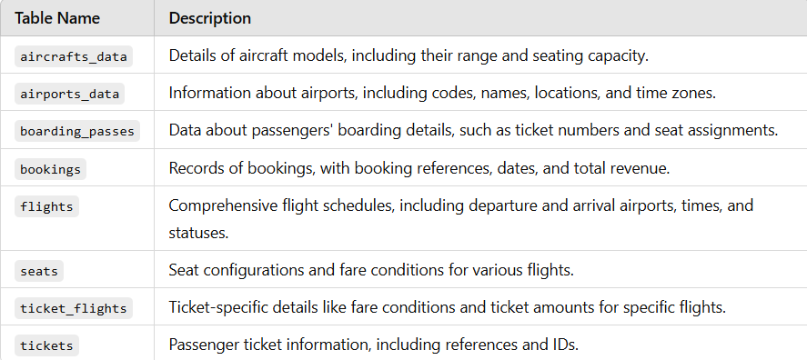

**Objectives:**

1. **Increase Occupancy rate:** By increasing the occupancy rate, we can boost the average profit earned per seat and mitigate the impact of the challenges we’re facing.
2. **Improving pricing strategy:** We need to develop a pricing strategy that takes into account the changing market conditions and customer preferences to attract and retain customers.
3. **Enhance customer experience:** We need to focus on providing a seamless and convenient experience for our customers, from booking to arrival, to differentiate ourselves in a highly competitive industry and increase customer loyalty.

The end goal of this task would be to identify opportunities to increase the occupancy rate on low-performing flights, which can ultimately lead to increased profitability for the airline.

**Key Insights and Analyses:**

**Plane Capacity Analysis**

* The analysis highlighted planes with more than 100 seats, identifying their frequency and contribution to overall operations.
* The distribution of these aircraft types indicates a reliance on mid-to-large-capacity planes for major routes.

**Ticket Bookings and Revenue Trends**

* A detailed time-series analysis revealed patterns in ticket bookings and total revenue generation.
* Bookings were observed to peak during specific months, likely due to seasonality or promotional campaigns.
* Revenue Insights: Significant growth in revenue was linked to higher bookings during peak travel seasons.

**Flight and Route Analysis**

* Top Airports: The busiest airports were identified based on departure and arrival frequencies.
* Popular Routes: High-traffic routes were determined, which may inform scheduling and capacity decisions.

In order to gain a deeper understanding of the trend of ticket bookings and revenue earned through those bookings, we have utilized a line chart visualization. Upon analysis of the chart, we observe that the number of tickets booked exhibits a gradual increase **from June 22nd to July 7th**, followed by a relative stable pattern **from July 8th until August**, with a noticeable peak in ticket bookings where the highest number of tickets were booked on a single day. It is important to note that the revenue earned by the company from these bookings is closely tied to the number of tickets booked. Therefore, we can see a similar trend in the total revenue earned by the company throughput the analyzed time period. These findings suggest that further exploration for the factors contributing to the peak in ticket bookings may be beneficial for increasing overall revenue and optimizing operational strategies.

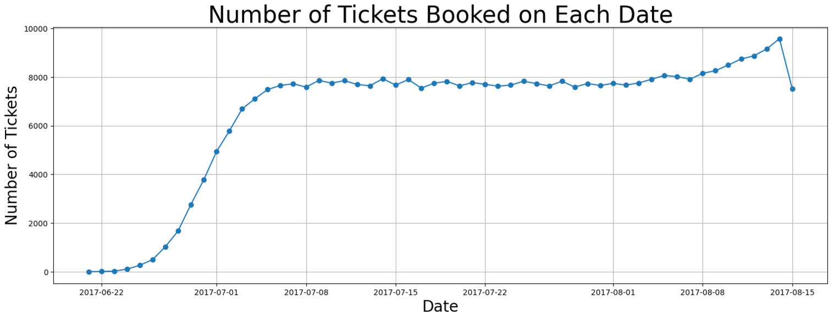

**Fig.1**

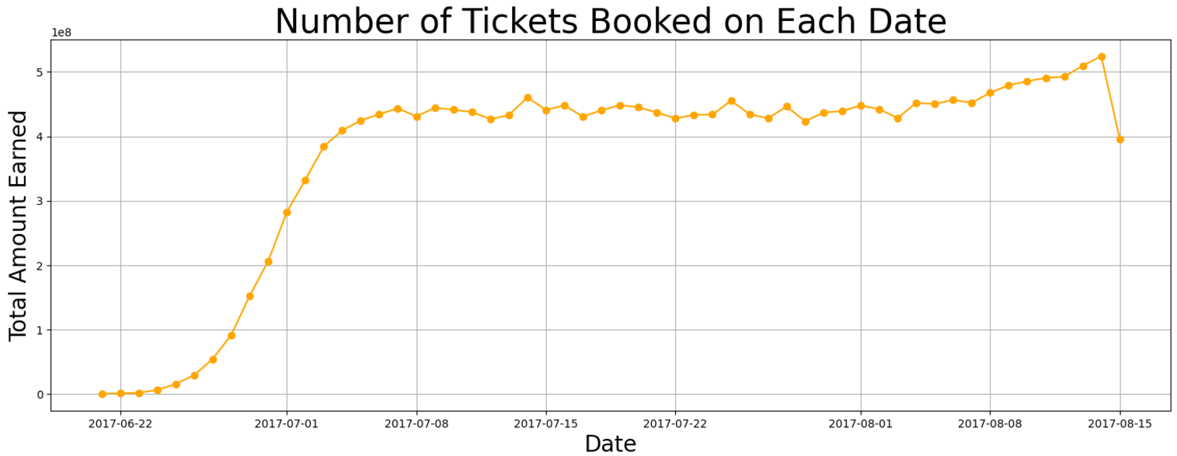

**Fig.2**

We were able to generate a bar graph to graphically compare the data after we completed the computations for the average costs associated with different fare conditions for each aircraft. The graph **Fig.3** shows data for three types of fares: business, economy, and comfort. It is worth mentioning that the comfort class is available on only one aircraft, the 773.

The CN1 and CR2 planes, on the other hand, only provide the economy class. When different pricing circumstances within each aircraft are compared, the charges for business class are consistently greater than those for economy class. This trend may be seen across all planes, regardless of fare conditions. 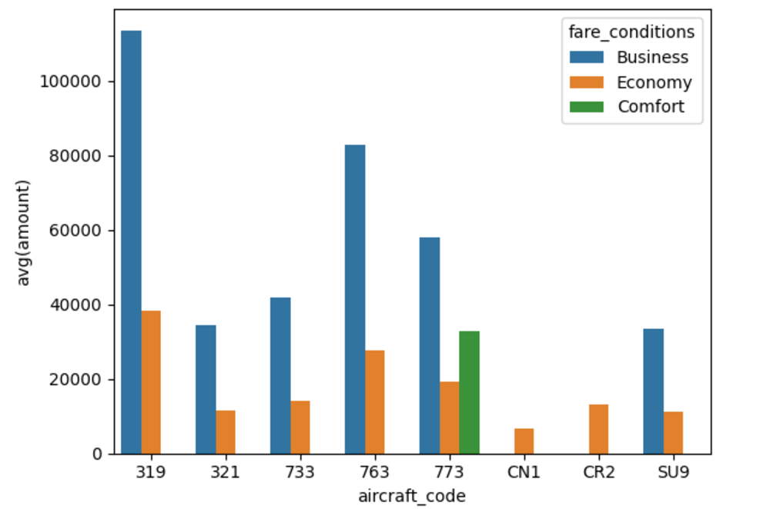

**Fig.3**

**Analyzing Occupancy Rate:**

Airlines must thoroughly analyze their revenue streams in order to maximize profitability. The overall income per year and average revenue per ticket for each aircraft are important metrics to consider. Airlines may use this information to determine which aircraft types and itineraries generate the most income and alter their operations appropriately. This research can also assist in identifying potential for pricing optimizing and allocating resources to more profitable routes. The below **Fig.4** shows the total revenue, total tickets and average revenue made per ticket for each aircraft. The aircraft with the highest total revenue is **SU9** and from the **Fig.3** it can be seen that the price of the business class and economy class is the lowest in this aircraft as its cost is less compared to others. The aircraft with least total revenue is **CN1**, and the possible reason behind this is it only offers economy class with very least price and it might be because of its poor conditions or less facilities.

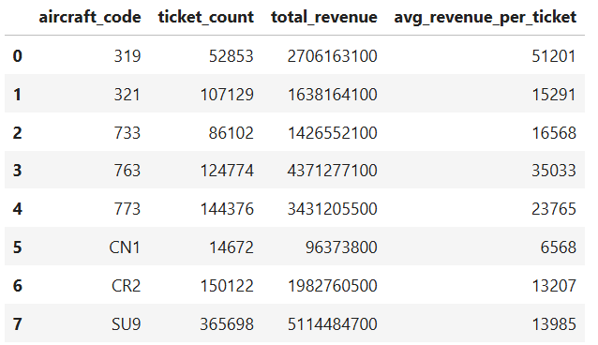

**Fig.4**

The occupancy per aircraft is another critical number to consider. Airlines may measure how successfully they fill their seats and discover chances to boost occupancy rates by using this metric. Higher occupancy rates can help airlines increase revenue and profitability while lowering operational expenses associated with vacant seats. Pricing strategy, airline schedules, and customer satisfaction are all factors that might influence occupancy rates. The below **Fig.5** shows the average booked seats from the total number of seats for each aircraft. The occupancy rate is calculated by dividing the booked seats by the total number of seats. Higher occupancy rate mans the aircraft seats are more booked and only few seats are left un-booked.

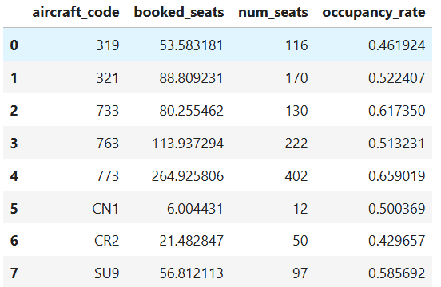

**Fig.5**

Airlines can assess how much their total yearly turnover could improve by providing all aircraft a 10% higher occupancy rate to further examine the possible benefits of raising occupancy rates. This research can assist airlines in determining the financial impact of boosting occupancy rates and if it is a realistic strategy. Airlines may enhance occupancy rates and revenue while delivering greater value and service to consumers y optimizing pricing tactics and other operational considerations. The below figure shows how the total revenue increased after increasing the occupancy rate by 10% and it gives the result that it will increase gradually so airlines should be more focused on the pricing strategies.

**4. Recommendations**

Based on the analysis:

1. **Focus on Peak Seasons**: Enhance marketing during high-demand months (e.g., July and December) to maximize revenue.
2. **Aircraft Optimization**: Align aircraft with demand patterns; deploy higher-capacity planes on popular routes.
3. **Route Expansion**: Explore adding flights on high-traffic routes or underserved areas to meet demand.

**Recommendations:**

**Based on the analysis:**

1. Focus on Peak Seasons: Enhance marketing during high-demand months (e.g., July and December) to maximize revenue.
2. Aircraft Optimization: Align aircraft with demand patterns; deploy higher-capacity planes on popular routes.
3. Route Expansion: Explore adding flights on high-traffic routes or underserved areas to meet demand.